PHASE 2
Design Document

Midstream College Quiz Night

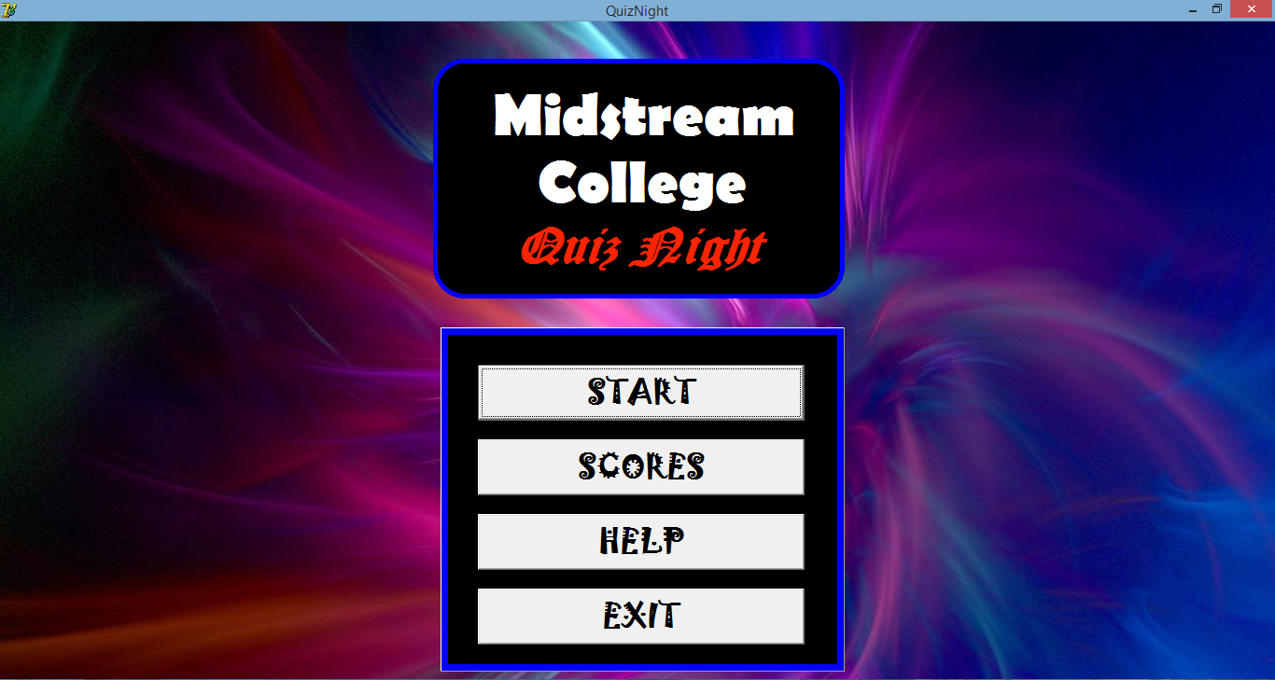

Developed by Bill Guo

Signoffs
Phase | Teacher | Date | Signature
2) Design Document | Mrs. Niebuhr

Table of Contents
1. Summary 3
2. Presentation Layer 4
2.1 GUI Screens 4
3. Business Layer 11
Sequencing 11
5. Database Layer 16
Explanation of data storage 16

1. Summary
Front Cover Form:
4 Buttons to navigate, help and exit program.

Grade Menu Form:
6 Buttons to get the correct participants depending on their grade.

Number Form:
1 SpinEdit to keep track of question number.
1 Button to go to the question.

Question Form:
Lots of images to keep track of what is going on.
Timer to time the time given to answer question.
Edit and RedOut to detect buzzer.

Scores Form:
1 Save Button to save the final score.
Display scores in good graphics.

Scoresheet Form:
Labels to keep track of data.

Teachers Form:
Labels to keep track of data.

2. Presentation Layer

2.1 GUI Screens

a) GUI screen: Front Cover
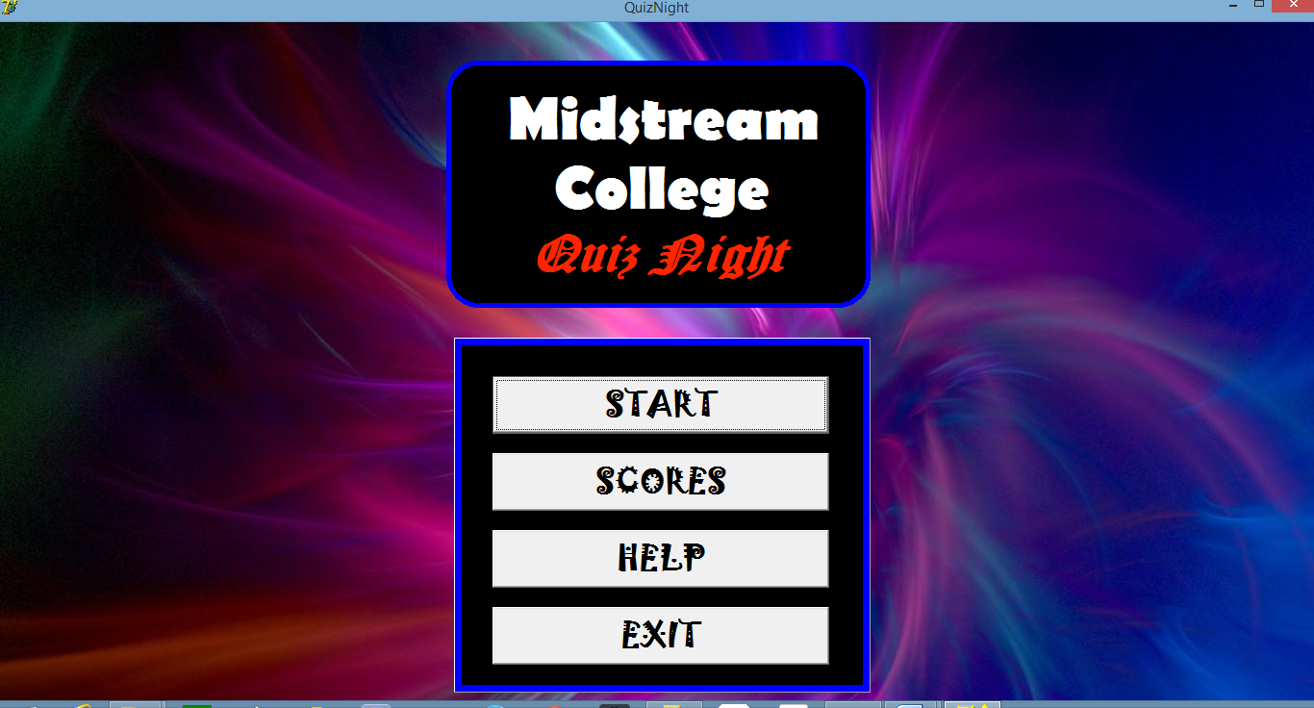
Description | It’s a welcome screen and shows the start of the application. Simple buttons to navigate to different aspect of the program.
Security Group | All users.
Data | None.
Actions | btnStart – Starts Quiz Night  btnScores – Final Scores Form  btnHelp – Help Form  btnExit – Exits Application

GUI screen: Grade Menu
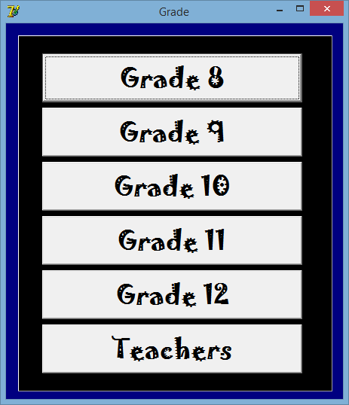
Description | Takes you to the right form to continue quiz night and gets the participants of the grade for the next quiz night event. It also gets the questions and answers.
Security Group | All users.
Data | Sends which grades textfile with the participants, answers, and questions to fetch and read from.
Actions | Clicking on any of the buttons takes you to the scoresheet where everybody is ready and starts on the score 0.

GUI screen: Scoresheet
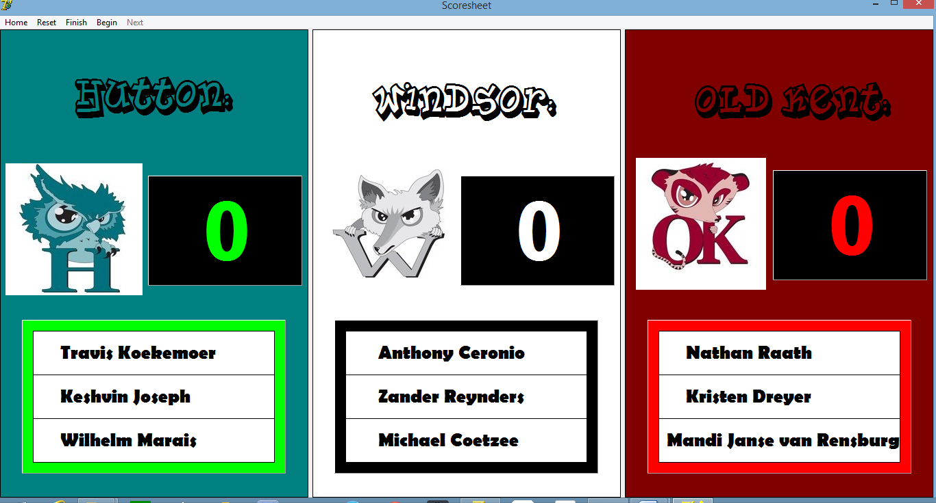
Description | Shows audience the participants and current scores of their Quiz Night competition.
Security Group | All users.
Data | None.
Actions | MenuHome – returns to Home screen. (Front Cover)  MenuReset – resets the scores if a wrong point was awarded to the wrong team.  MenuFinish – saves the quiz night of the grade when the quiz is done  MenuBegin – begins the Quiz Night  MenuNext – carries on with the previous question of the Quiz Night

GUI screen: Number
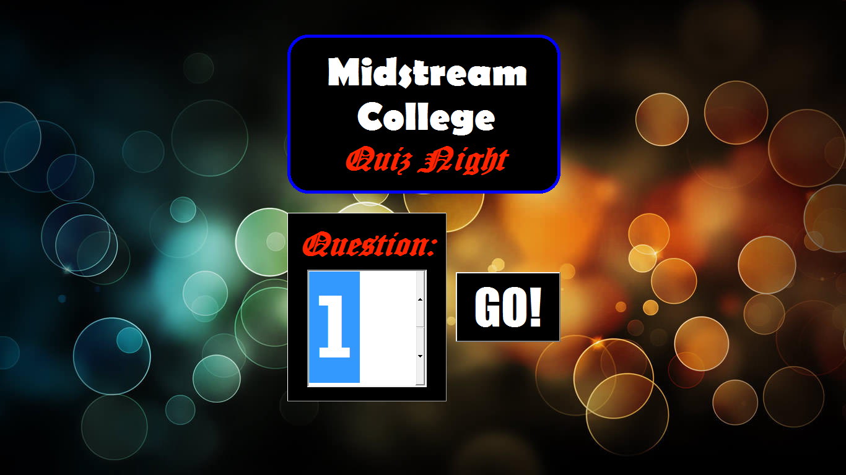
Description | Lets all teams and audience know that the next question is coming up and must get ready and quiet down.
Security Group | All users.
Data | iCounter – keep track of question.
Actions | btnGO – Goes to the question form with the question and timer, and which can detect buzzers.

GUI screen: Question
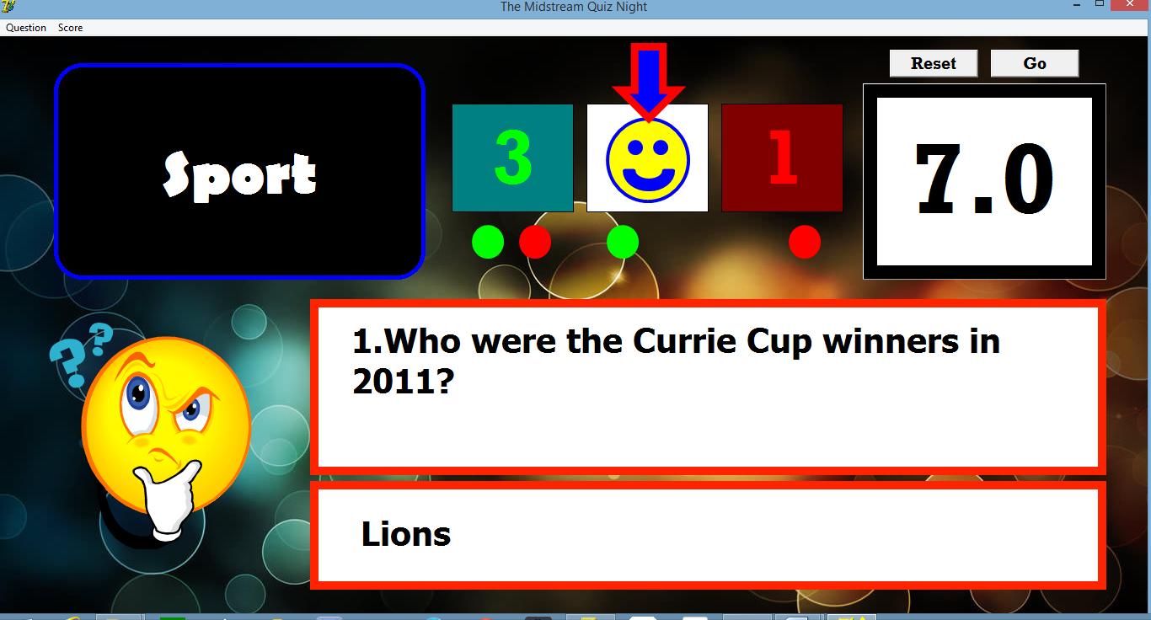
Description | Where the action is seen by the audience and can be monitored by the person running Quiz Night. Shows the questions and answers to the audience. Detects buzzers and is where houses are awarded points.
Security Group | All users.
Data | Global variable sPoint to award point once 5 questions have been answers to move on to the next section.
Actions | Buzzer detects 1,2, or 3 as text. On KeyUp – once key has been pressed, application determines who is 1st, 2nd and 3rd to press the buzzer. Timer runs as soon as this is detected. Person running the program chooses if they got the question correct or incorrect. Arrows help in keeping track of what is going on.

GUI screen: Teachers
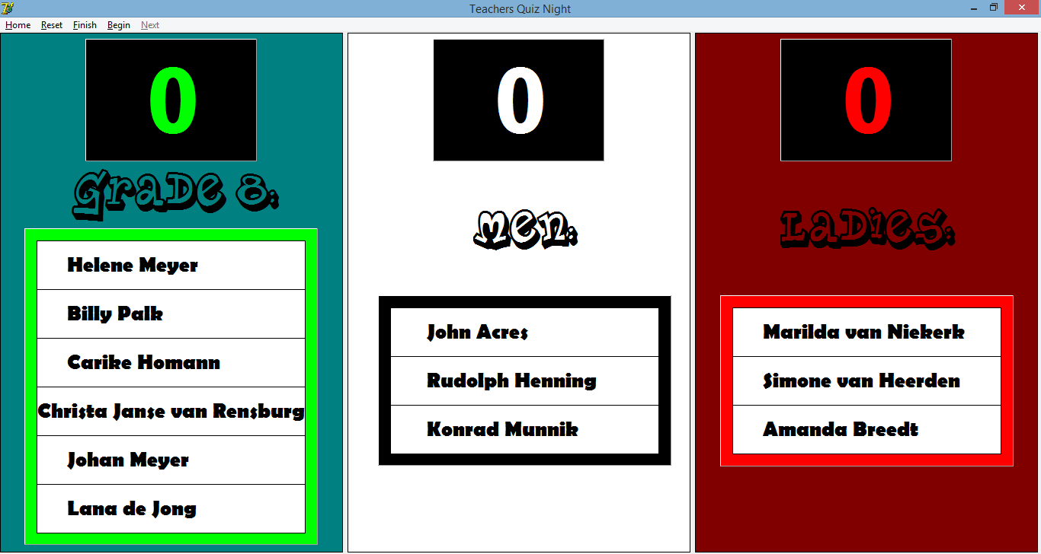
Description | Scoresheet of Teachers – longer groups.
Security Group | All users.
Data | None.
Actions | Same as scoresheet of learners. Menu is the main action or only action to do something with the form.

GUI screen: Final Scores
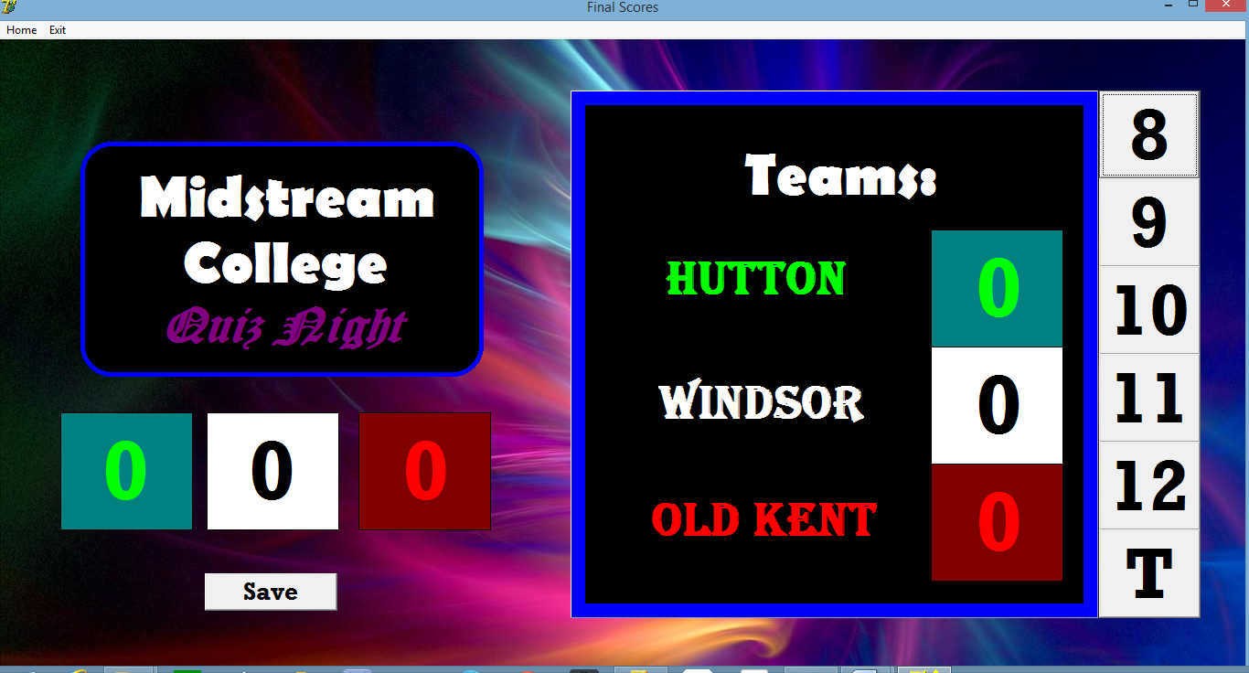
Description | Final Score page to show or determine who the House winner was of the competition.
Security Group | All users.
Data | Textfiles with the results of the quiz nights done by the grades and teachers. Retrieves who was 1st, 2nd and 3rd and awards points accordingly.
Actions | Grade buttons on the side are clicked to add on to the total.  Save button saves the final scores into a textfile and Quiz Night is done.

GUI screen: Help
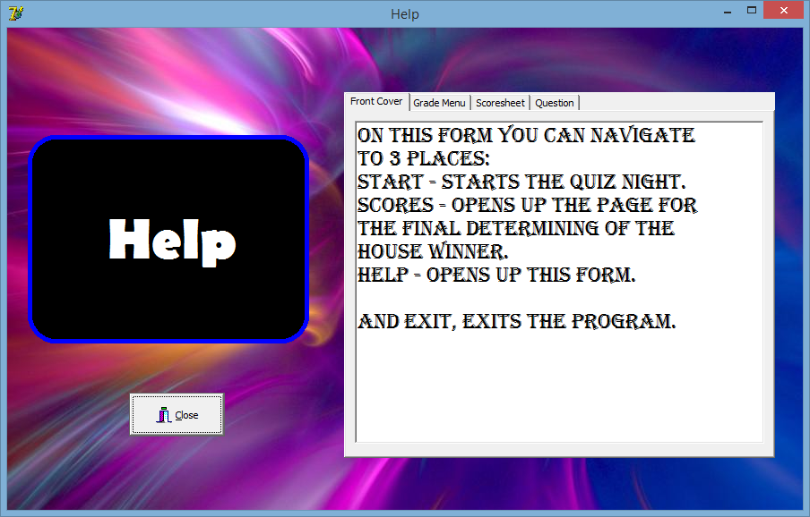

Description | Help page displays a manual on how to use the program.
Security Group | All users.
Data | None.
Actions | btnClose – return to Home screen – front cover.
2.2. Reports
No Reports are generated. A screen to a projector is needed to display the program and the quiz to the audience.

3. Business Layer

Sequencing
- Front Cover
  - Welcome page to audience, participants and the event.
  - Click btnStart to begin Quiz Night.
- Grade Menu
  - Choose the grade that’s going to take on the Quiz Night.
  - This get the participants names from textfiles.
- Scoresheet
  - Displays to the audience the participants names and scores.
- Question
  - Next section of the questions is going to begin.
- Number
  - Gets everybody ready before starting.
  - Fair way and nobody can press the buzzers since they have been disabled.
- Question
  - Question is shown and buzzers are activated.
  - Determines who gets a point and shows the answer to the question.
- Scoresheet
  - After every 5 questions, a new section starts and so the audience gets to see the scores after every section.
  - Once 40 questions have been answered, winner is shown and the grades’ Quiz Night is saved.
  - Return home to start new grade or teachers’ Quiz Night.
- Scores
  - Once all grades and teachers Quiz Night has been finished, the House winner can be determined here.
By adding up all the grades scores and teachers, the house winner is determined and these final results can be saved to end Quiz Night.
4. Objects / Classes to be developed

Class Name: THouse
Purpose of class: Keep track of each house’s data.
Fields
Field Name | Data type | Description
fArrParticipants | Array[1..3] of string | Particpants partaking for their house.
fHouse | String | Houses name.
fGrade | Integer | Grade partaking.
fScore | Integer | Current score house is on.
Methods
Method name | Data type (if typed) / void | Description
Constructor create | Void | Creates an object/instance of the class.
Destructor destroy | Void | Free class from memory.
Function get – each | String, integer | Gets private variables to use.
Procedure set – each | String, integer | Sets private variables to something else.
Function toString | String | Gets all data of class into one string.
Function getParticipant(iNo) | string | Gets participant names.

Class Name: TQuiz
Purpose of class: Keep track of whole Quiz Night Event.
Fields
Field Name | Data type | Description
fArrHouses | THouse | The three different houses.
fGrade | Integer | Grade partaking.
fArrAnswers | String | Answers for the grade.
fArrQuestions | String | Questions for the grade.
Methods
Method name | Data type (if typed) / void | Description
Constructor create | Void | Creates an instance of the class.
Destructor destroy | Void | Free class from memory.
Procedure set – all | String, integer, THouse | Sets private variables.
Function get - all | String, integer, THouse | Gets private variables to use.

Class Name: TScores
Purpose of class: Final score page to save scores and add all scores up.
Fields
Field Name | Data type | Description
fHScore | integer | Hutton score.
fWSCore | Integer | Windsor score.
fOKSCore | Integer | Old Kent score.
Methods
Method name | Data type (if typed) / void | Description
Constructor create | Void | Creates an instance of the object.
Destructor destroy | Void | Frees class from memory.
Procedure save | Void | Saves final results to textfile.
Procedure sort | void | Sorts out final results before saving.

Class Name: TTeachers
Purpose of class: Teachers questions and answers get.
Fields
Field Name | Data type | Description
fArrAnswers | string | Teacher’s answers for Quiz Night.
fArrQuestions | String | Teacher’s questions for Quiz Night.
Methods
Method name | Data type (if typed) / void | Description
Constructor create | Void | Creates an instance of the class.
Destructor destroy | Void | Frees class from memory.
Procedure setAnswers  Procedure setQuestions | String | Sets the teachers questions and answers from textfiles.
Function getAnswers(iNo)  Function getQuestions(iNo) | String | Gets teachers questions and answers for the audience and event.

5. Database Layer
No Databases have been used. Only textfiles was used.

Questions Folder:
- Contains 6 textfiles. Every grade and teachers questions. Format: Questions are numbered from 1-40. E.g.
- Who is Bob?
Answers Folder:
- Contains 6 textfiles. Every grade and teachers answers. Format: Each answer on its own line and only the answer.
Participants Folder:
- Contains 6 textfiles. Every grade and teachers participants. Format: Hutton: - Next three lines on their own the house participants, followed by an empty line and repeat for then Windsor and then Old Kent.
Scores Folder:
- Contains 6 textfiles. Every grade and teachers scores if they were saved. Format: The house winners letter followed by their score.
Final Folder:
- Contains one textfile – Final.txt. In the format: Houses First Letter followed by the score with no spaces. E.g.W8

Explanation of data storage
Textfiles was used because a large amount of text had to be retrieved and only string was retrieved, not other data. Textfiles were perfect as they are like Microsoft word but just simpler. Using textfiles, text was gotten directly from the textfile and there was no confusioins when retrieving or writing data to and from them. Textfiles are easy to read and write to.

